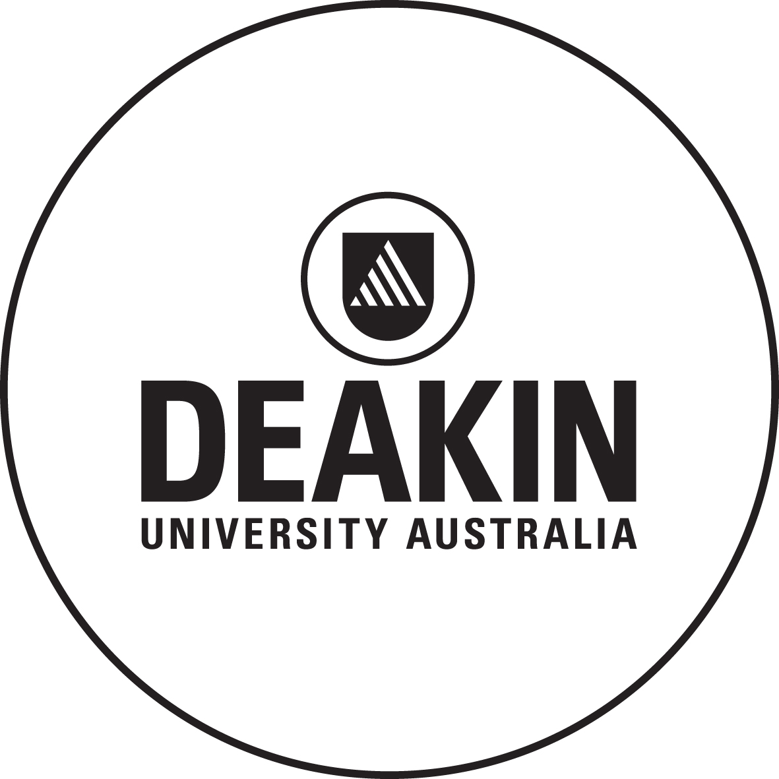

**Deakin University**

MyCONTEXT Cancer Record

Project Scope

Project Sponsor

http://contexthealth.com

Project Team

Team #

Anish Shrestha: 218430313

Sukhvinder Kaur: 217506256

Parag Shrestha: 218353519

Aishwarya Thota: 217432146

Yenumula Sai Vamsi: 218599457

Document Version 1.4

# Document Revision History

|  |  |  |  |  |  |
| --- | --- | --- | --- | --- | --- |
| **Date** | **Version** | **Editor** | **Reason** | **Supervisor Signature** | **Client Signature** |
| 29-03-2019 | 1.0 | Anish | Initial details added |  |  |
| 02-04-2019 | 1.1 | Vamsi | Motivation/ Problem Description |  |  |
| 2-4-2019 | 1.2 | Aishwarya | Value proposition/ Core idea |  |  |
| 2-4-2019 | 1.3 | Sukhvinder | Project Description |  |  |
| 4-4-2019 | 1.4 | Anish | corrections |  |  |

# Motivation / Problem Description

A lot of data has been generated day-by-day from different domains like Health, Ecommerce, financial, Weather, Intelligence. Health domain is the major source of data generation as a lot of medical records are been generated that gives an in-depth about the health condition which contain some sensitive information in it. Medical researches and paramedical companies need this data for research, which helps them to understand about the effectives of usage of drug.

Because of the difficult to main these records and the sensitive information they contain made the public health records difficult to access for the paramedical companies and researchers.

There has been a huge leap in the security of data with the introduction of Blockchain on which are trying to focus as a part of this project. The aim of the project is implementation of Distributed Ledger Technology (DLT) and provide safe and secure access of the records of cancer patients to the researchers and paramedical companies as well as allow the patients to have control over their medical records. To access these medical records research groups and paramedical companies must make a bid and patients can respond via DLT.

# Context

The data of the cancer patients is privileged data which is not easily accessible. The sharing of the data is so difficult and can take lots of organization resources and which may lead to a compromise of data security. It is too hard to “own” the data of patients. If that would be possible then there will be paradigm shift in the clinical detail. Medical researchers and pharmacist need the real time data to invent new medicines so that it can help in improvement in condition of cancer patients.

We will use the blockchain technology by keeping our data in the encrypted form and blockchain itself is a new technology in which data is kept in the decentralised. DLT will allow us to create the platform where we will manage the patients, hospitals and clinics where they will register themselves and users will have to share records, validate it.

# Value Proposition

## Commercial

#### **1. Improved cash flow**

Smart contracts created by a DLT system can make immediate automatic payment of invoices as soon as a transaction is completed. Rather than waiting for several layers of authorisation when the invoice is issued, everyone from the supplier to the project manager to the quality controller can see what is required and sign off as the work happens. Once everything is complete, the transaction block closes and a payment can be triggered automatically.

#### **2. Streamlined supply chain operation**

How can you be sure of the provenance of all the individual elements of goods you make or buy? DLT provides a chain of transparent and immutable records which can provide evidence that an ingredient is truly organic, or that health and safety procedures are being followed in a factory, for example.

#### **3. Automatic follow-ups**

If you are providing a service with repeat appointments, issuing a follow up could be an automatic process as soon as the first appointment is complete. The client may also be required to confirm the follow up in the system. This could apply to anything from healthcare to consultancy, reducing the burden of administration and the risk of no-shows.

#### **4. Fewer intermediaries to deal with**

If an agreement can be reached without a middleman, if it can be “disintermediated”. It represents both an opportunity – reduced costs – and a threat. If you run any kind of agency, then simply processing a transaction will no longer be enough. You will have to add value to your clients.

The travel industry has already tackled a similar problem, with direct online bookings displacing traditional agents. The best providers have pushed back to deliver a valuable service over and above booking management. This is going to be replicated in other industries, so be prepared.

#### **5. Digital identity**

How many times do you have to produce your passport, driving licence or utility bills to prove who you are? If all your information was held in an immutable chain, this could be used to verify your identity whenever required. Work is already under way at the United Nations to develop DLT-based identities for refugees and other people who have no life records.

**Social:**

Delivers a communication/support tool to a target market that is often overlooked

1. Social impact investment.

2. Renewable energy exchanges

3. More secure personal data

4. Big data collection

5. Direct access to funding for charities

6. New fundraising strategies

**Technological:**

Provides a standalone product with little external dependencies

1.Transparacy

2. Security and reliability.

3.Accurate Accounting.

4. Quality Assurance.

5.Traceability.

**Operational**:

1.Operational simplification

2.Regulatory efficiency improvement

3.Counterparty risk reduction

4.Clearing and settlement time reduction

5.Fraud minimisation

Promotes communication and collaboration irrespective of user skill level

# Core Idea/User Stories/Requirements

# Target Deliverables

The following goals have been identified as dependencies that need to be addressed early in the life cycle of the project.

1. **Cancer Patients Dataset:** A sample of realistic synthetic dataset of patient records necessary to exercise the prototype blockchain implementation.
2. **Data Tool:** A tool for specific data collection for patient care details across many unlinked records.
3. **service to add Transaction on blockchain:** Access control logic and module that allows the permissioning of an individual heath record on a blockchain, explicit consent at each point of interaction.
4. **Web App for CURD:** CRUD of individual health records implements on a blockchain.

# Roadmap

|  |  |  |  |  |
| --- | --- | --- | --- | --- |
| The MyContext Product Roadmap | | | | |
| Date | 26th March - 8th April | 9th April - 22nd April | 30th April - 13th May | 14th May- 27th May |
| Name | Sprint 1 | Sprint 2 | Sprint 3 | Sprint 4 |
| Goal | * Research about DLT * Research on Patient health record formats * Upskill yourself * Create a realistic synthetic dataset for prototype * Select Landing Page and development platform. | * Setup Development Environment and start coding. * Learn Hyperledger and Design block chain database for Application. * Create landing page and Rest API or tool to collect data. * Create web app for application | * Implement blockchain data base * Add authentication and authorization. mechanism in web app * Add pages for CURD operation in web app. * Access control logic and module that allows | * CRUDE of individual health records implements on a blockchain Research on Patient health record formats * Testing * Deploy prototype with CURD feature. |
| Feature | * Scope document that all agreed upon. * Datasets of cancer patient’s health record. * Resource and skill collection for Application. | * Database Design for blockchain. * Project initiation and git implementation with version control. * Introduction page of web application. | * get/post/head/delete service in blockchain. * authentication and authorization. * Web app for CURD | * Working prototype for testing. * Presentation of application. * Hosted web app for curd operation. * Project Final Documentation |
| Metrices |  |  |  |  |

## Execution Strategy

## Sprint 1

**Goals** :

Construction of a realistic synthetic dataset of patient records necessary to exercise the prototype blockchain implementation.

* Research about DLT
* Research on Patient health record formats
* Upskill yourself
* Create a realistic synthetic dataset for prototype
* Select Landing Page and Platform for development

**Target deliverables**

* Attain skill set
* Scope document (this document) that has been agreed upon by all parties
* Communication and delivery expectations that has been agreed upon by all parties

## Sprint 2

**Goals**

 A tool for specific data collection for patient care details across many unlinked records:

* Database design, data structure and data format / schema of transaction will be analysed and agreed upon.
* Prepare a suitable environment within a docker container to encapsulate and execute the transformation process.
* Tools/API for data collection of patient record.

**Target deliverables**

* A docker container encapsulating the transformation engine
* Development environment setup.
* Web application for user interaction for CURD
* A deployment document that describes how to install and use the application

## Sprint 3

**Goals**

Access control logic and module that allows the permissioning of an individual heath record on a blockchain, explicit consent at each point of interaction:

* Add authentication and authorization mechanism for every transaction in blockchain.
* Webapp/Restful API for CURD operation.

**Target deliverables** Implement blockchain data base

* Access control logic and module that allows
* Add authentication and authorization.
* Add pages for CURD operation in web app.
* A deployment document that describes how to install and use the solution
* Sample dataset to validate the transformation engine reported results

## Sprint 4

**Goals**

CRUD of individual health records implements on a blockchain

**Final deliverables**

* Working prototype for testing.
* Presentation of application.
* Hosted web app for curd operation.
* Project Final Documentation

# Limitations, Constraints and Considerations

The limitations, constraints and considerations of the project are as follows:

* limited resource and Project details provided. ie. Sample dataset of real patients and Data flow information.
* Scope documents need clients review.
* Blockchain technology is new and has vast opportunities and limitation that yet to discovered.
* Our deliverables my changed through each sprint.
* Our team is small and new in blockchain technology and need to attain different skill set for completion of this project.